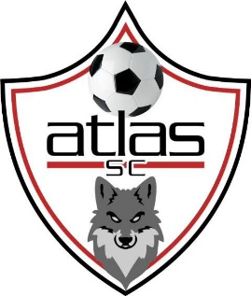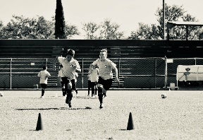
ATLAS SC ORANGE COUNTY – CAPISTRANO SUMMER CUP 2026
Team Waiver of Liability and Release Form (One per Team)
This form must be completed for each soccer coach or team manager (participant) and, if the player is under 18-years old, must be signed by the player’s parent or legal guardian next to the team roaster. No player will be allowed to participate in ASCSAI (CAPISTRANO SUMMER CUP 2026), games or any other events conducted by ASCSAI AND (CAPISTRANO SUMMER CUP 2026) It this form properly executed, and on file the day of the event or before starting any events I, the undersigned, in consideration for my voluntary participation in organized soccer, do hereby willfully acknowledge that my signature below attests to my understanding and agreement that:
My Coach or Team manager status will be kept in good standing. I will not compromise myself in such a way as to do harm to the league or tournament, knowing that players may be dismissed from participation, with possible loss of payment or dues, for violent conduct or unsportsmanlike behavior on or off the field of play. I agree to pay for any and all damages to any property or indemnities caused by me willfully, negligently, or otherwise.
Soccer is a physical, contact, sport that involves the risk of injury. I assume all risks and hazards associated with the participation of my players in the sport. I am in proper physical condition to participate in soccer practices and games and have no illness, disease or existing injury or physical defect that would be aggravated the participation of my players. Players will inform if the status changes. I further acknowledge that this risk may involve loss or damage to participants or my property, including the risk of death, or other unforeseen consequences, including those which may be due to the unavailability of immediate emergency medical care. I have a current medical consent form in force. I will assure participants (My Players) will wear shin guards, properly-fitted and appropriate shoes, and other protective equipment (e.g., mouth-pieces), as provided by soccer rules, to all events.
ASCSAI (CAPISTRANO SUMMER CUP 2026) does not have personal injury insurance that covers the players, Coaches or spectators in participation. Therefore, I should have a current, active, personal injury insurance policy in force, which covers your player’s participation. Under any condition, Me as a coach or Team manager 1 am responsible for any and all medical expenses arising from our team players participation, both in practices and games or any events under ASCSAI (CAPISTRANO SUMMER CUP 2026) and while travelling to and from these events. You have the right and responsibility to inspect the equipment and facilities prior to events and, if I believe that anything may be unsafe, I will advise the organizers or supervisor of the condition and may refuse to participate. Participation assumes consent.
I authorize our photograph, picture or likeness, and voice to appear in any documentary, promotion (including advertising), television, video, or radio coverage of any ASCSAI (AFCOCIC) tournament Events, without compensation.
I authorize that an unaltered copy of this form may be generated and given to the officers or directors of other leagues or tournaments in order to allow my participation in their soccer programs, if the form is required and I have requested to participate.
I hereby release, waive liability, discharge, hold harmless, indemnify, and covenant not to sue, the United States Soccer Federation, the State Association, the Club, the league and tournament, their associated directors, administrators, officers, managers, employees, coaches, trainers, volunteers, sponsors and advertisers, and other agents, estates or executors, from any and all liability incurred in the conduct of, and my participation in, their soccer programs. This includes owners, lessors, and lessees of premises, municipalities, government agencies, successors, heirs, and assigns.
I have completely read this document and fully understand its contents. I acknowledge that I have given up substantial rights by accepting this document and that I do so voluntarily. My signature attests to this on behalf of myself and my executors, personal representatives, administrators, heirs, next-of-kin, successors, and assigns.
For those individuals eighteen (18) years of age and older:
Team Name ____________________________ Age Category_______________ Gender Male__________ Female __________
___________________________ __________________________ _____________________
Head Coach Name (PRINT) Head Coach Signature Date Signed

Mobil Number ( ) _______ - _________ Email __________________________________@_____________________
Address __________________________________________City__________________________State_____________ Zip__________
___________________________ _____________________________ ____________________
Team Manager Name (PRINT) Team Manager Signature Date Signed

Mobil Number ( ) _______ - _________ Email _________________________@_____________________
Address _____________________________________City________________________________State____________ Zip__________
As the coach or Team manager natural guardian or legal guardian of the participant, I hereby agree to the foregoing Waiver of Liability and Release for, and on behalf of, the participant (player/minor) named in the Team Roster. I hereby bind myself, the minor, and all other assigns to the terms of the Waiver of Liability and Release. I represent and certify that I have the legal capacity and the authority to act for, and on behalf of, the minor in the execution of this Waiver of Liability and Release.

